**DAILY ONLINE ACTIVITIES SUMMARY**

|  |  |  |  |  |  |  |  |  |
| --- | --- | --- | --- | --- | --- | --- | --- | --- |
| **Date:** | **19-05-2020** | | | | | **Name:** | **Preethi** | |
| **Sem & Sec** | **6th - B** | | | | | **USN:** | **4AL17CS065** | |
| **Online Test Summary** | | | | | | | | |
| **Subject** | | **CGV** | | | | | | |
| **Max. Marks** | | **60** | | **Score** | | | **56** | |
| **Certification Course Summary** | | | | | | | | |
| **Course** | **Deep Learning Onramp** | | | | | | | |
| **Certificate Provider** | | | **MathWorks** | | **Duration** | | | **2 hours** |
| **Coding Challenges** | | | | | | | | |
| **Problem Statement:2 java programs and 1C Program** | | | | | | | | |
| **Status: Executed** | | | | | | | | |
| **Uploaded the report in GitHub** | | | | | **yes** | | | |
| **If yes Repository name** | | | | | <https://github.com/atish-shanbhag/Updates/tree/master/19may20> | | | |
| **Uploaded the report in slack** | | | | | **Yes** | | | |

Online Test Details: (Attach the snapshot and briefly write the report for the same)

First I A of CGV

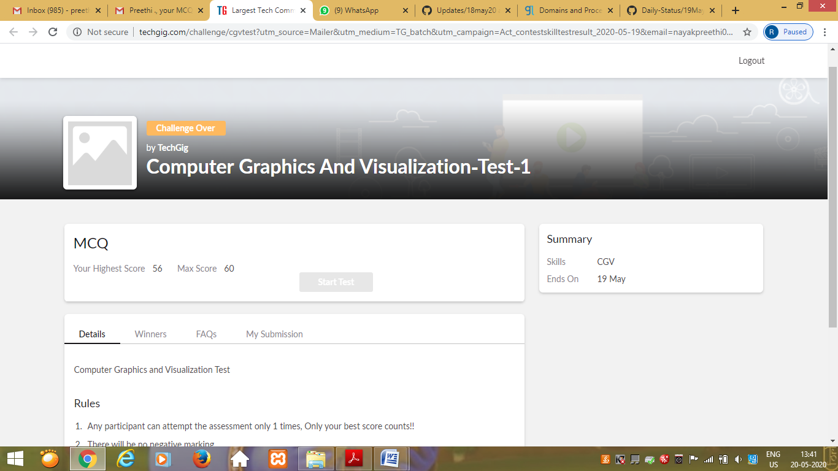

Certification Course Details: (Attach the snapshot and briefly write the report for the same)

­­

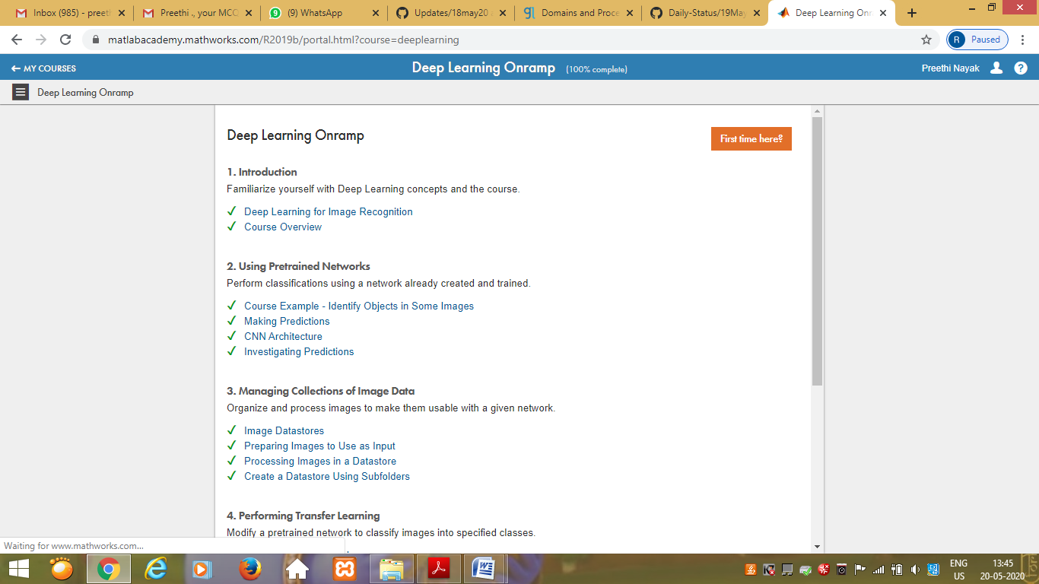

Coding Challenges Details: (Attach the snapshot and briefly write the report for the same

Output screen shots

Program 1

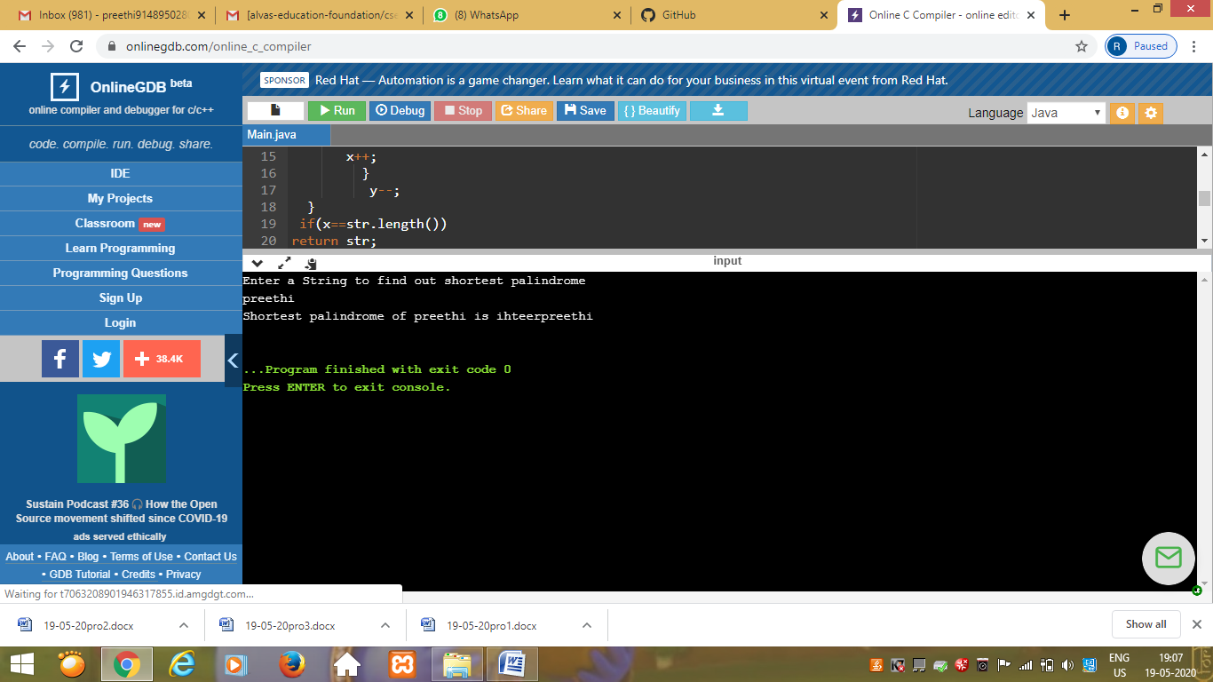

program 2

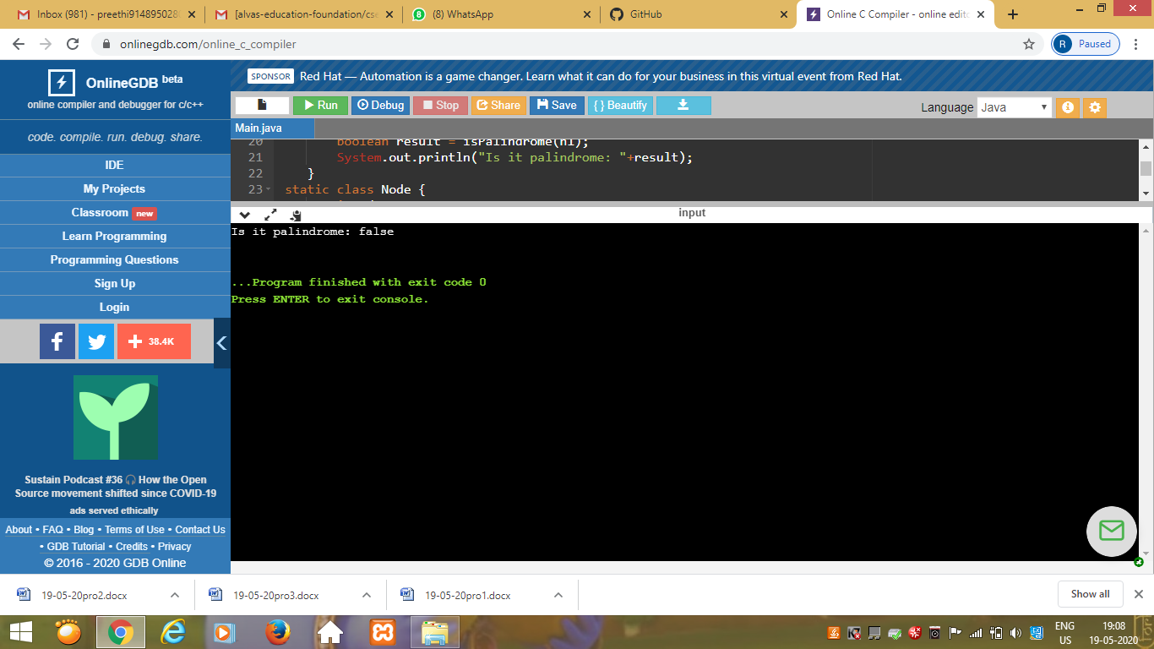

program 3

